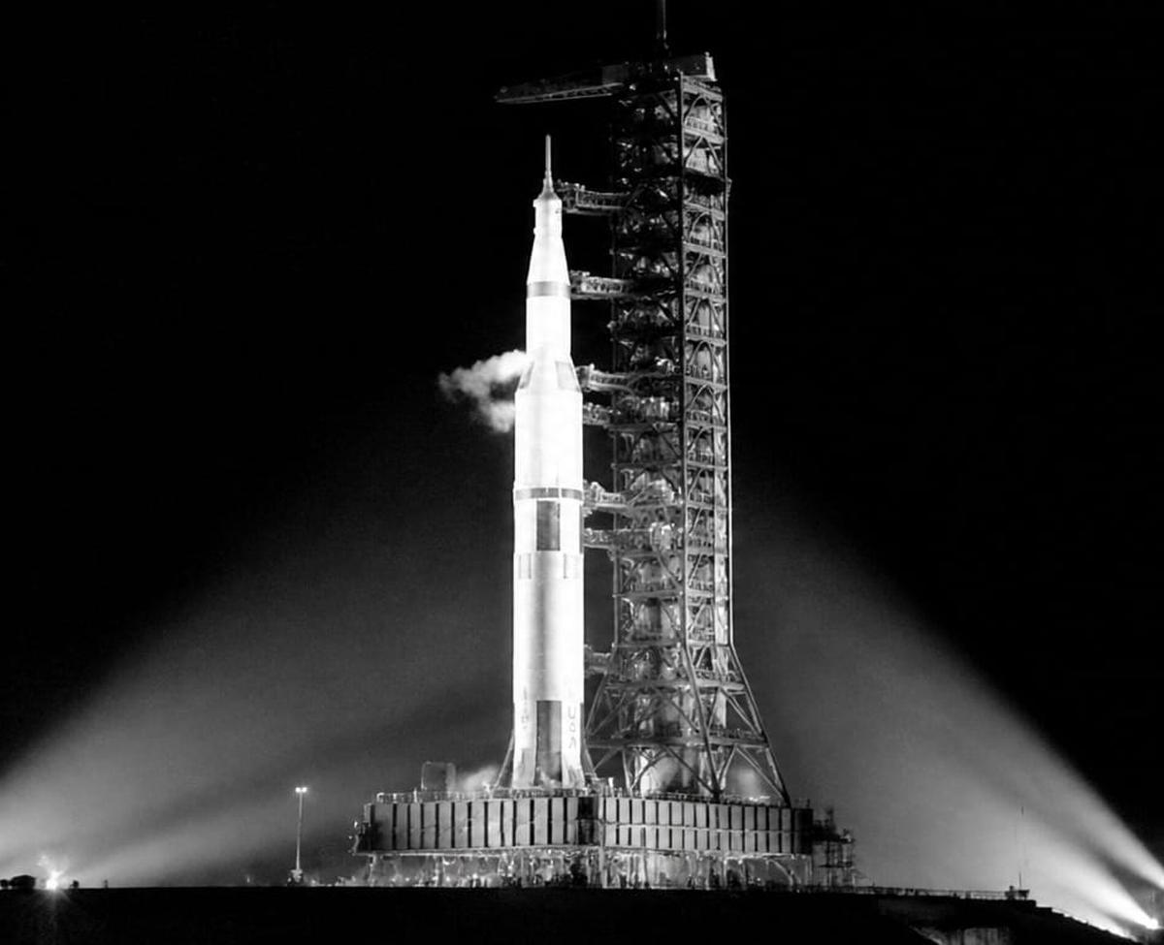
Saturn V — Launch Complex 39A Kennedy Space Center · tallest rocket ever flown
JANUARY 2027
SUN | MON | TUE | WED | THU | FRI | SAT
3 |  |  |  |  | 1 | 2
10 | 4 | 5 | 6 | 7 | 8 | 9
17 | 11 | 12 | 13 | 14 | 15 | 16
24 | 18 | 19 | 20 | 21 | 22 | 23
31 | 25 | 26 | 27 | 28 | 29 | 30
Libraria Spei et Miraculorum · Colossal Structures 2027

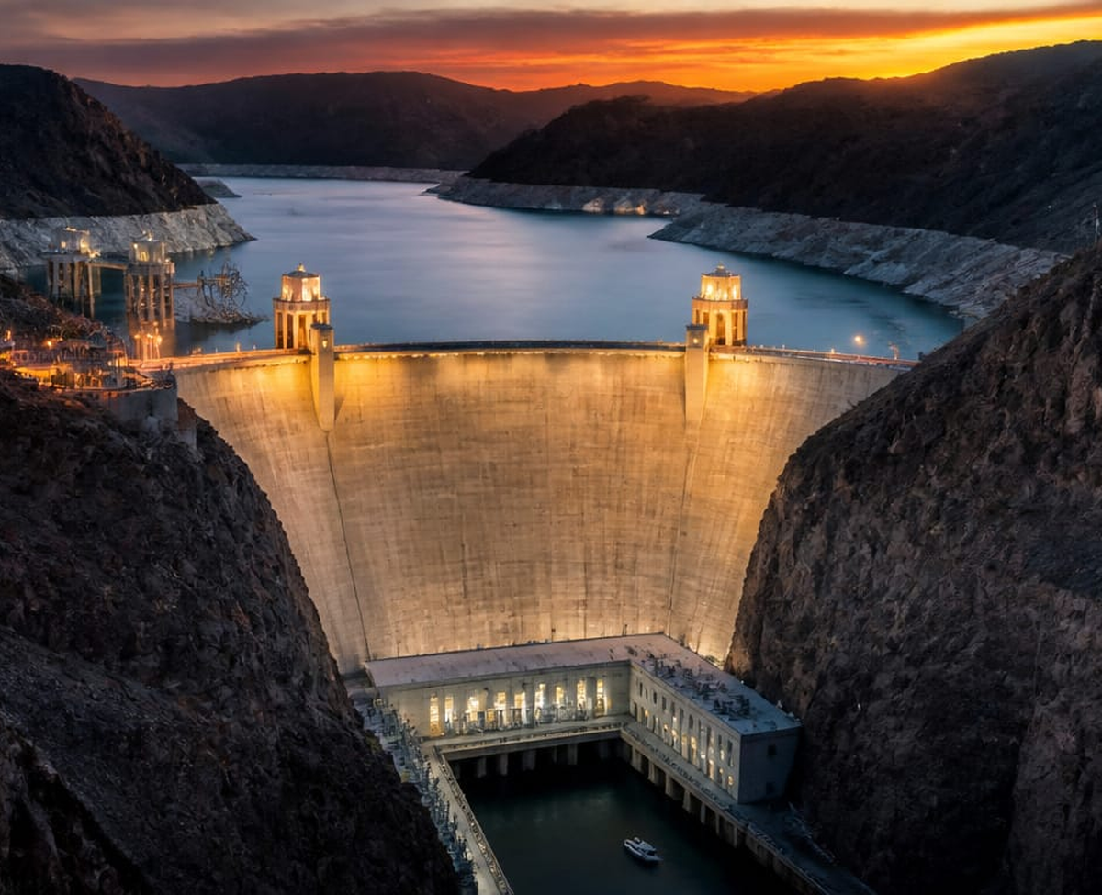
Hoover Dam Nevada / Arizona · 726 feet tall, built 1931–1936
FEBRUARY 2027
SUN | MON | TUE | WED | THU | FRI | SAT
7 | 1 | 2 | 3 | 4 | 5 | 6
14 | 8 | 9 | 10 | 11 | 12 | 13
21 | 15 | 16 | 17 | 18 | 19 | 20
28 | 22 | 23 | 24 | 25 | 26 | 27
Libraria Spei et Miraculorum · Colossal Structures 2027

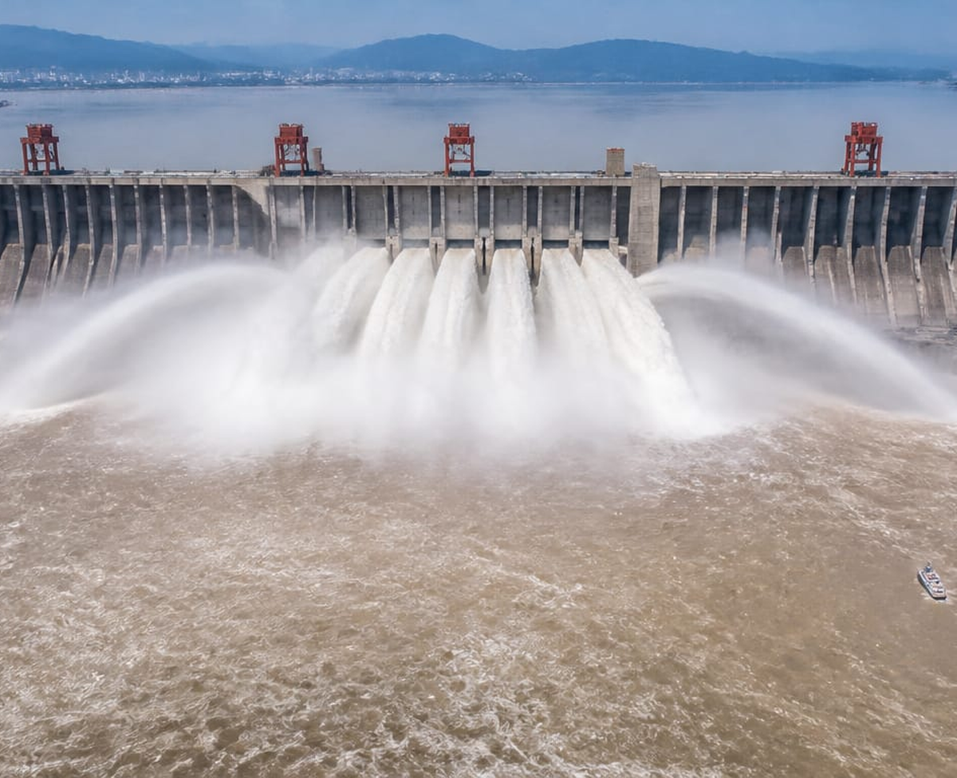
Three Gorges Dam — Flood Release Yangtze River, China · world's largest power station
MARCH 2027
SUN | MON | TUE | WED | THU | FRI | SAT
7 | 1 | 2 | 3 | 4 | 5 | 6
14 | 8 | 9 | 10 | 11 | 12 | 13
21 | 15 | 16 | 17 | 18 | 19 | 20
28 | 22 | 23 | 24 | 25 | 26 | 27
 | 29 | 30 | 31
Libraria Spei et Miraculorum · Colossal Structures 2027

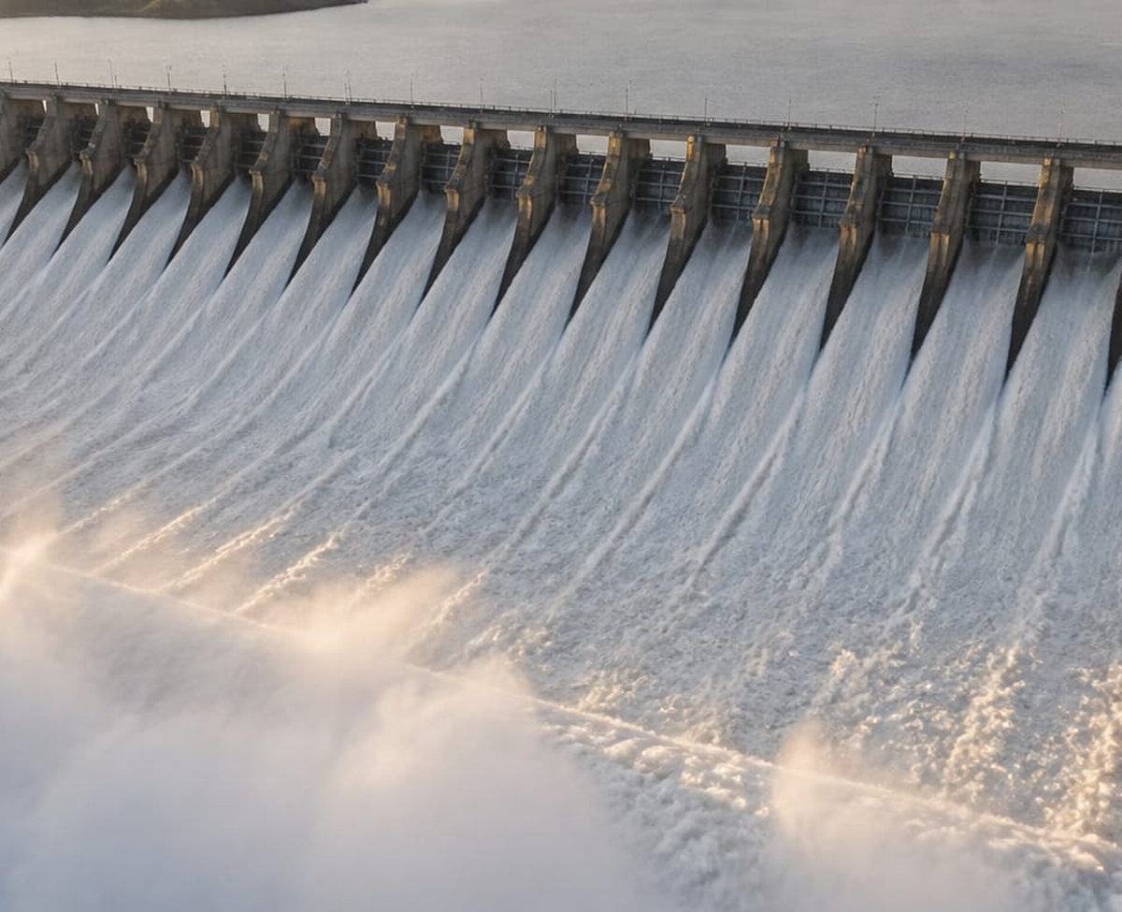
Itaipu Dam — Spillway in Full Flood Brazil / Paraguay · once the world's largest hydroelectric plant
APRIL 2027
SUN | MON | TUE | WED | THU | FRI | SAT
4 |  |  |  | 1 | 2 | 3
11 | 5 | 6 | 7 | 8 | 9 | 10
18 | 12 | 13 | 14 | 15 | 16 | 17
25 | 19 | 20 | 21 | 22 | 23 | 24
 | 26 | 27 | 28 | 29 | 30
Libraria Spei et Miraculorum · Colossal Structures 2027

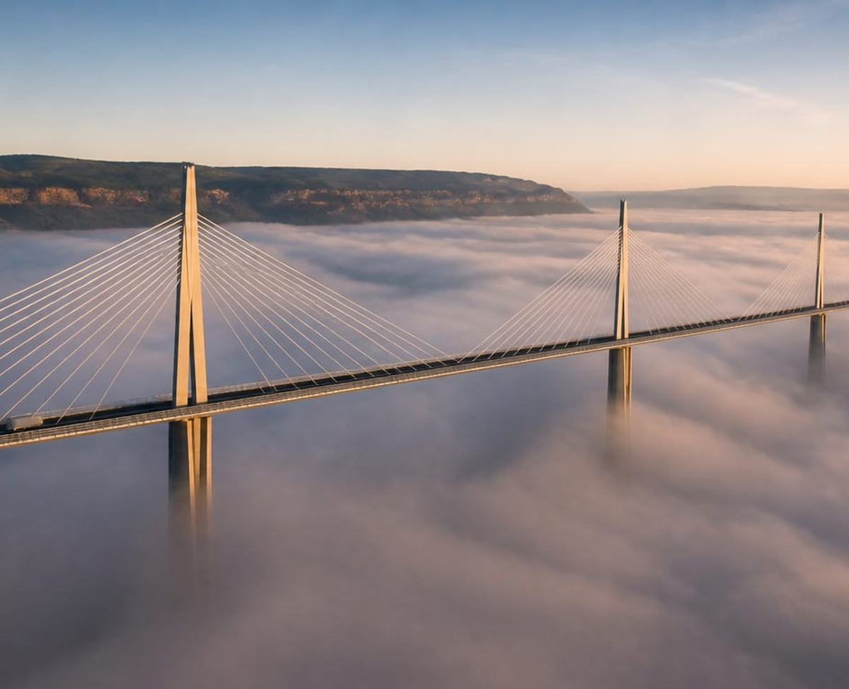
Millau Viaduct Aveyron, France · taller than the Eiffel Tower
MAY 2027
SUN | MON | TUE | WED | THU | FRI | SAT
2 |  |  |  |  |  | 1
9 | 3 | 4 | 5 | 6 | 7 | 8
16 | 10 | 11 | 12 | 13 | 14 | 15
23 | 17 | 18 | 19 | 20 | 21 | 22
30 | 24 | 25 | 26 | 27 | 28 | 29
 | 31
Libraria Spei et Miraculorum · Colossal Structures 2027

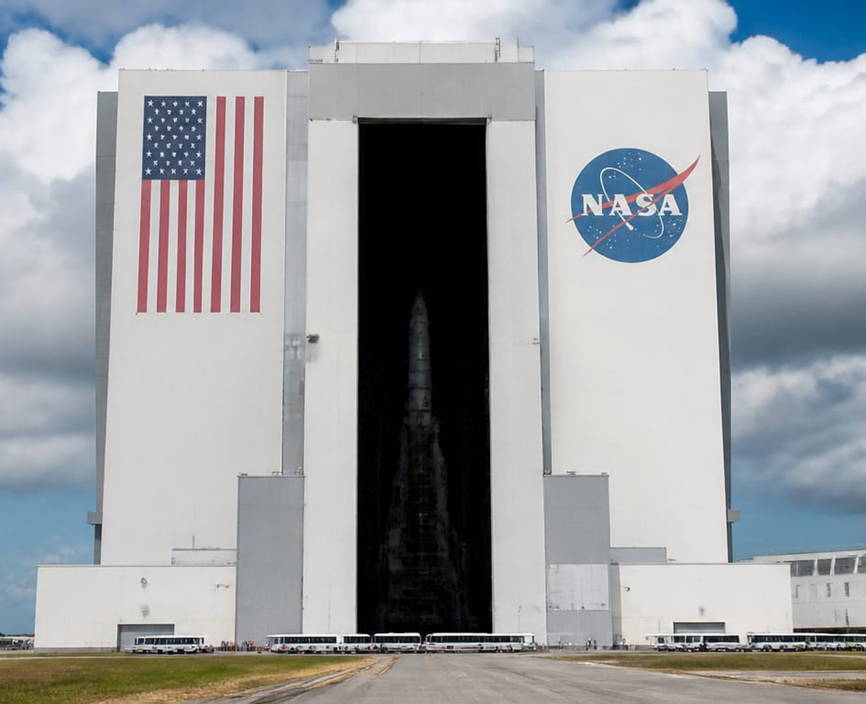
Vehicle Assembly Building Kennedy Space Center · so large it has its own weather inside
JUNE 2027
SUN | MON | TUE | WED | THU | FRI | SAT
6 |  | 1 | 2 | 3 | 4 | 5
13 | 7 | 8 | 9 | 10 | 11 | 12
20 | 14 | 15 | 16 | 17 | 18 | 19
27 | 21 | 22 | 23 | 24 | 25 | 26
 | 28 | 29 | 30
Libraria Spei et Miraculorum · Colossal Structures 2027

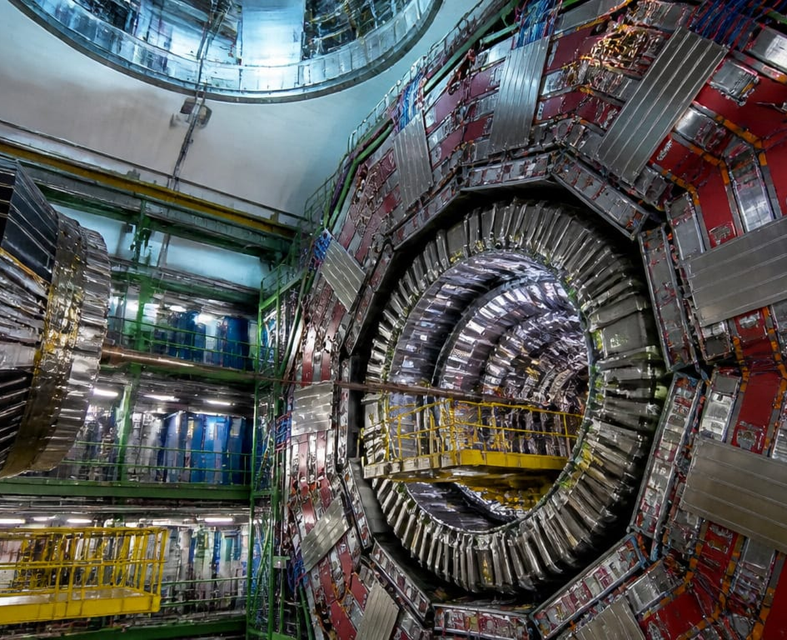
CERN — Large Hadron Collider Geneva, Switzerland · the largest machine ever built
JULY 2027
SUN | MON | TUE | WED | THU | FRI | SAT
4 |  |  |  | 1 | 2 | 3
11 | 5 | 6 | 7 | 8 | 9 | 10
18 | 12 | 13 | 14 | 15 | 16 | 17
25 | 19 | 20 | 21 | 22 | 23 | 24
 | 26 | 27 | 28 | 29 | 30 | 31
Libraria Spei et Miraculorum · Colossal Structures 2027

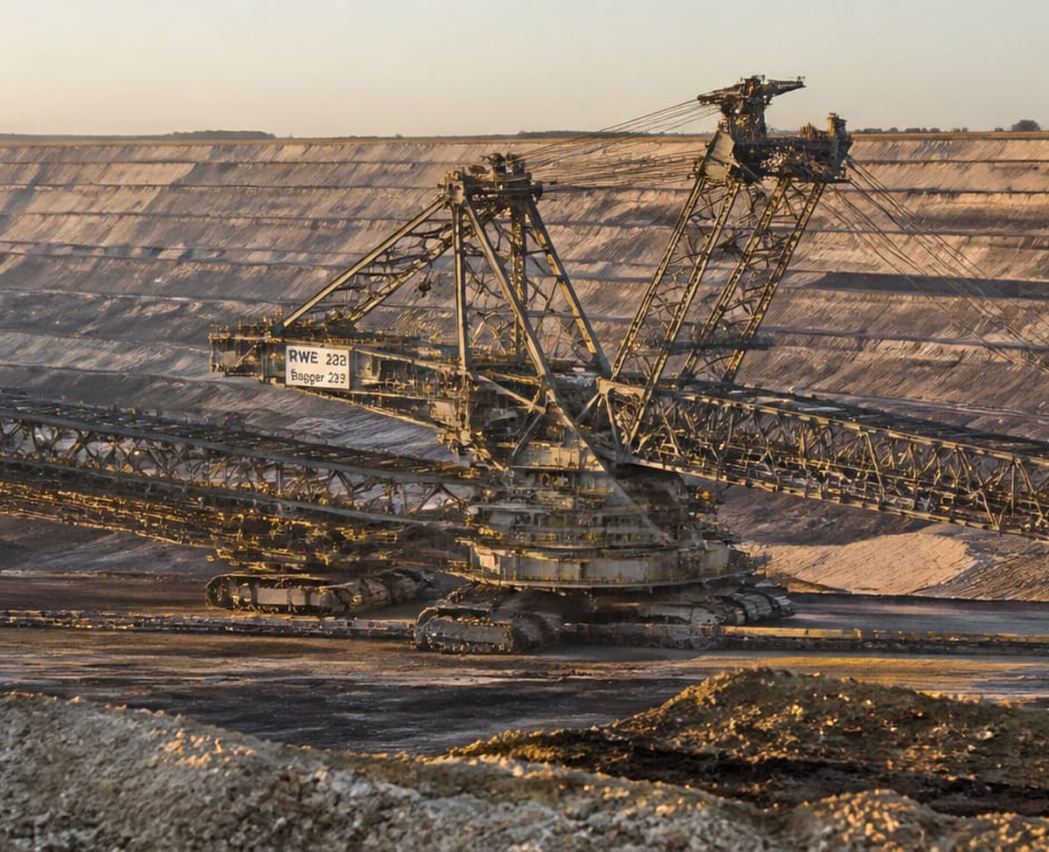
Bagger 293 — Bucket-Wheel Excavator Germany · heaviest land vehicle ever built: 14,200 tons
AUGUST 2027
SUN | MON | TUE | WED | THU | FRI | SAT
1
8 | 2 | 3 | 4 | 5 | 6 | 7
15 | 9 | 10 | 11 | 12 | 13 | 14
22 | 16 | 17 | 18 | 19 | 20 | 21
29 | 23 | 24 | 25 | 26 | 27 | 28
 | 30 | 31
Libraria Spei et Miraculorum · Colossal Structures 2027

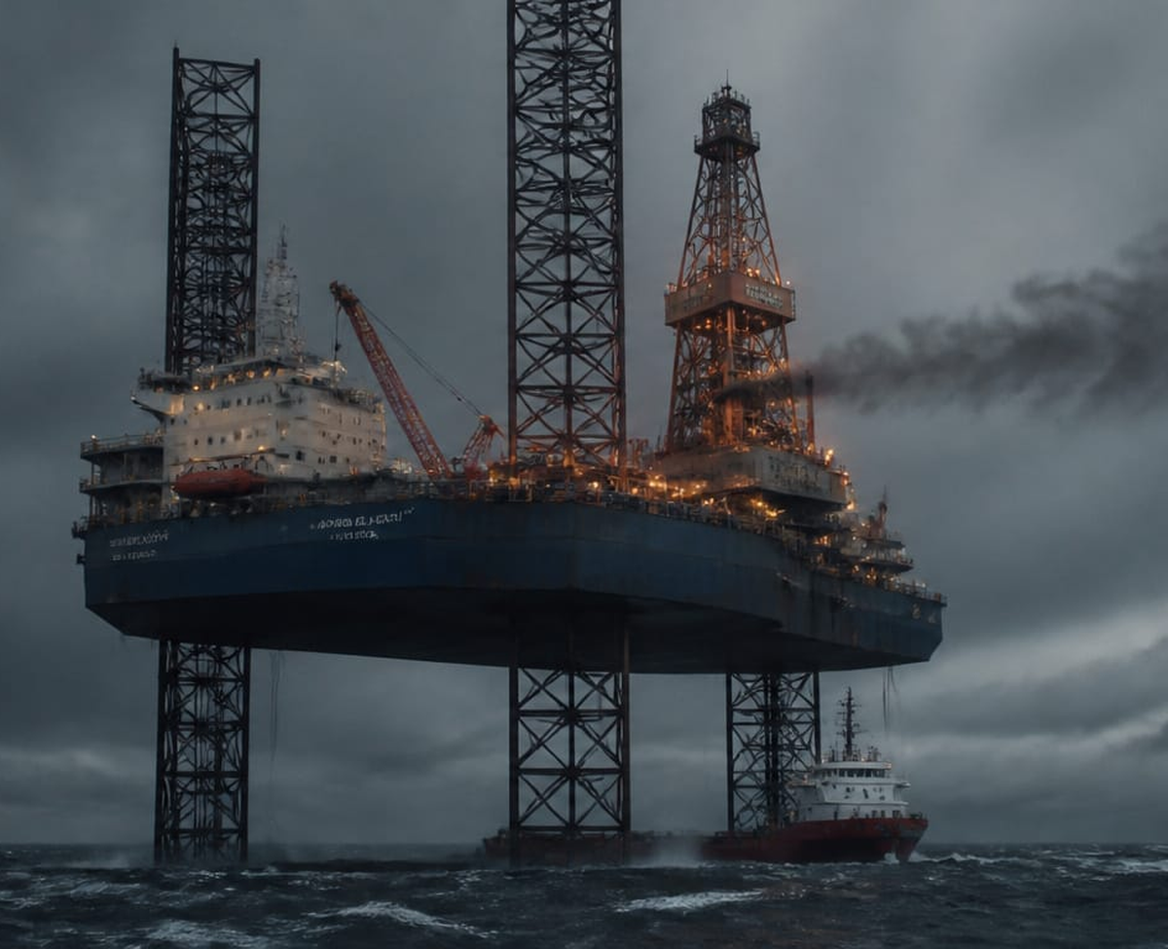
Jack-Up Drilling Rig — North Sea Self-elevating platform standing on the seabed in open ocean
SEPTEMBER 2027
SUN | MON | TUE | WED | THU | FRI | SAT
5 |  |  | 1 | 2 | 3 | 4
12 | 6 | 7 | 8 | 9 | 10 | 11
19 | 13 | 14 | 15 | 16 | 17 | 18
26 | 20 | 21 | 22 | 23 | 24 | 25
 | 27 | 28 | 29 | 30
Libraria Spei et Miraculorum · Colossal Structures 2027

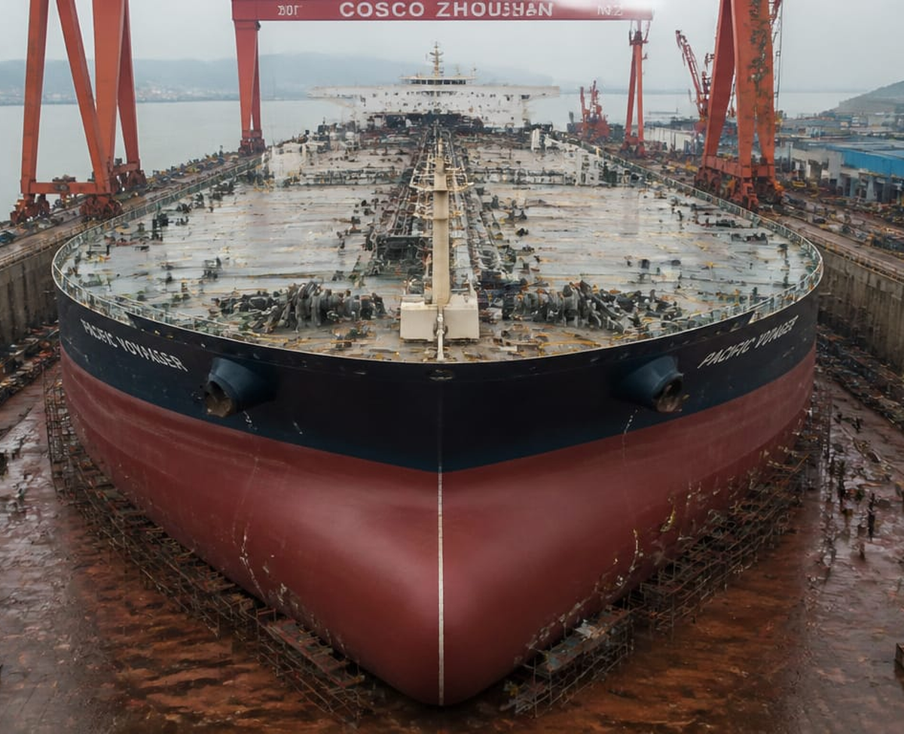
VLCC Supertanker Very Large Crude Carrier · longer than four city blocks
OCTOBER 2027
SUN | MON | TUE | WED | THU | FRI | SAT
3 |  |  |  |  | 1 | 2
10 | 4 | 5 | 6 | 7 | 8 | 9
17 | 11 | 12 | 13 | 14 | 15 | 16
24 | 18 | 19 | 20 | 21 | 22 | 23
31 | 25 | 26 | 27 | 28 | 29 | 30
Libraria Spei et Miraculorum · Colossal Structures 2027

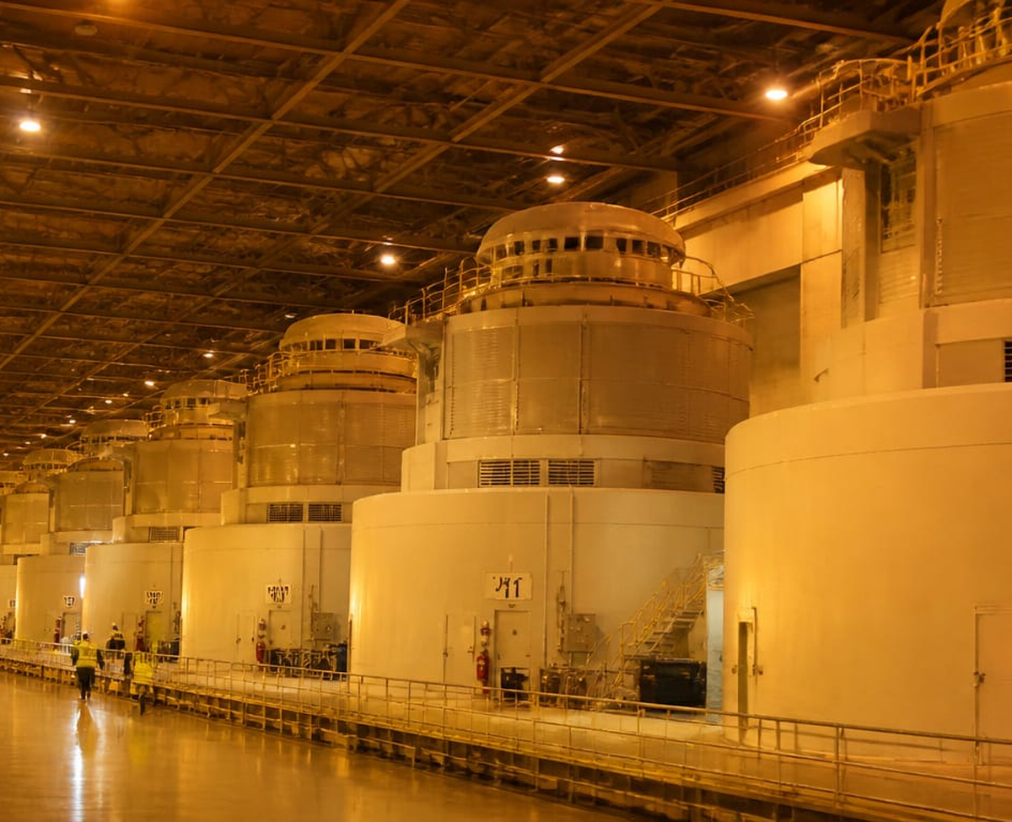
Grand Coulee Dam Powerhouse Columbia River, Washington · largest U.S. power plant
NOVEMBER 2027
SUN | MON | TUE | WED | THU | FRI | SAT
7 | 1 | 2 | 3 | 4 | 5 | 6
14 | 8 | 9 | 10 | 11 | 12 | 13
21 | 15 | 16 | 17 | 18 | 19 | 20
28 | 22 | 23 | 24 | 25 | 26 | 27
 | 29 | 30
Libraria Spei et Miraculorum · Colossal Structures 2027

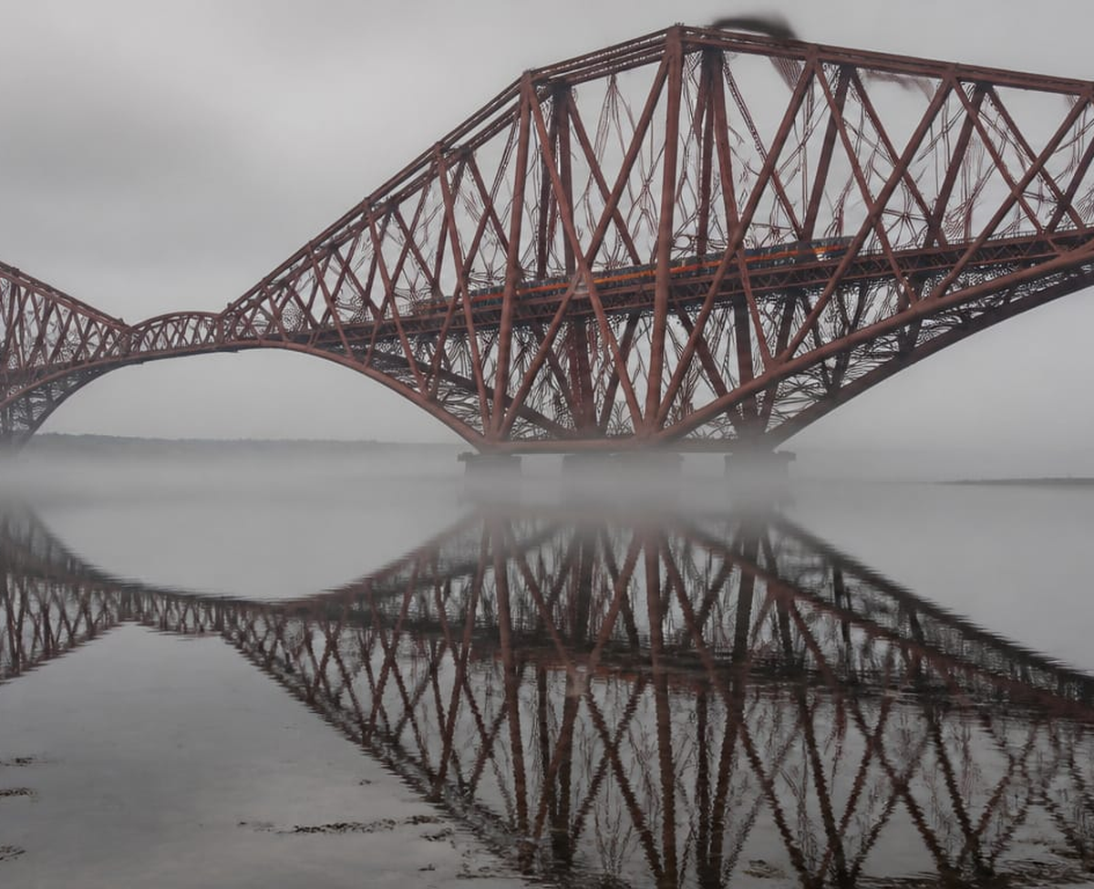
Forth Bridge Scotland · cantilever railway bridge, opened 1890, still in daily use
DECEMBER 2027
SUN | MON | TUE | WED | THU | FRI | SAT
5 |  |  | 1 | 2 | 3 | 4
12 | 6 | 7 | 8 | 9 | 10 | 11
19 | 13 | 14 | 15 | 16 | 17 | 18
26 | 20 | 21 | 22 | 23 | 24 | 25
 | 27 | 28 | 29 | 30 | 31
Libraria Spei et Miraculorum · Colossal Structures 2027

