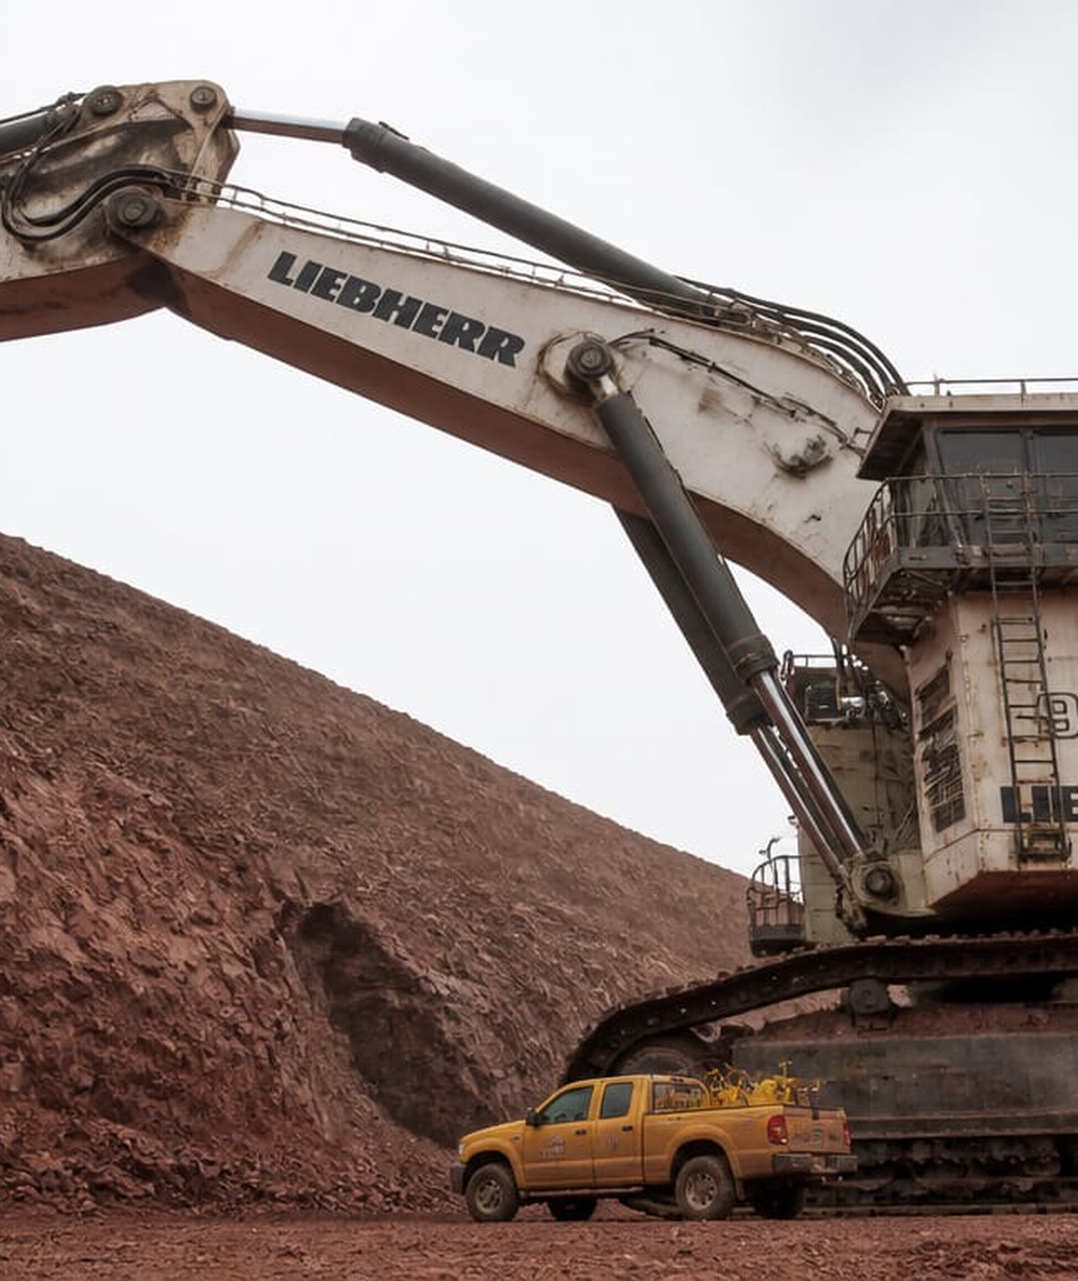
HEAVY EQUIPMENT
2027

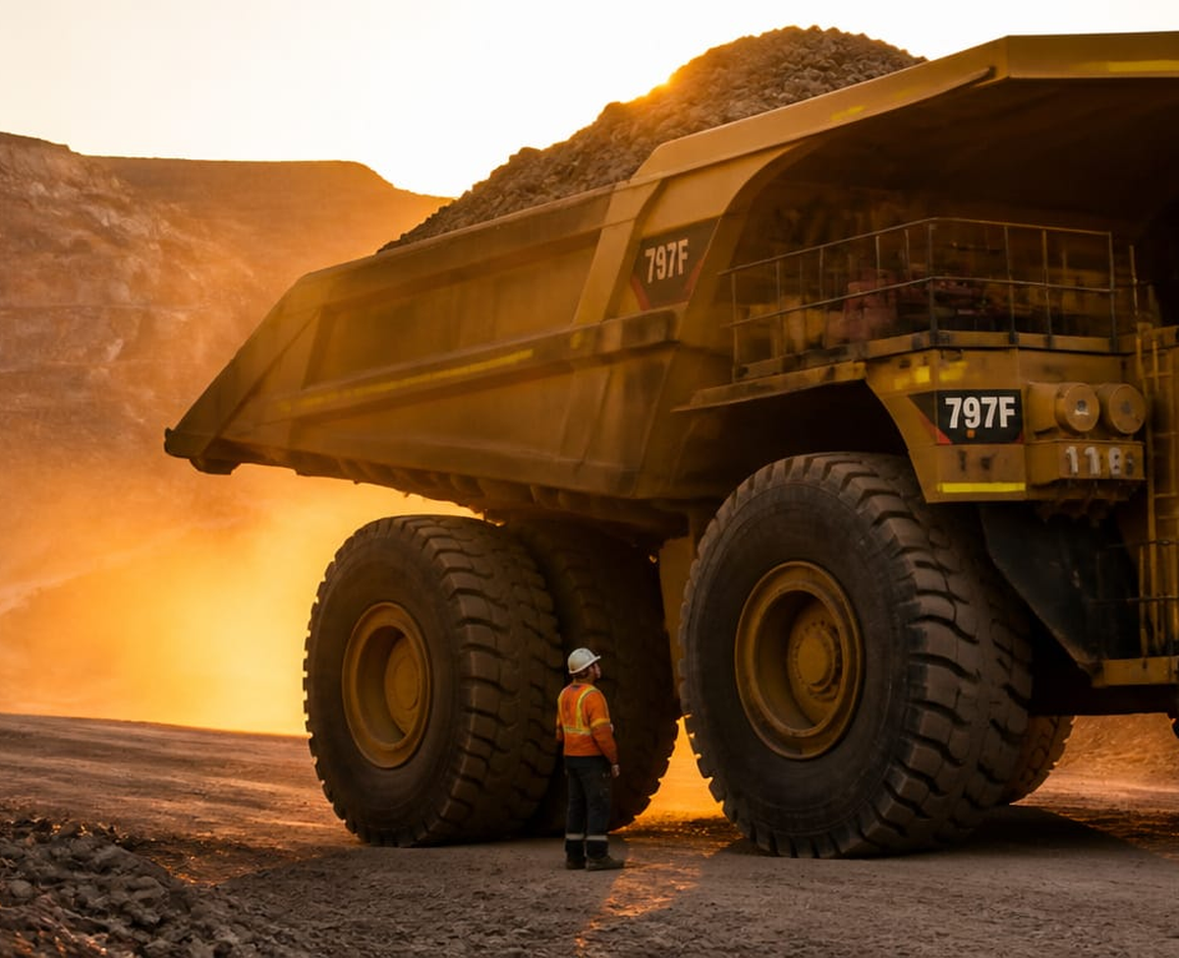
Caterpillar 797F Mining haul truck · payload 400 tons · three stories tall
JANUARY 2027
SUN | MON | TUE | WED | THU | FRI | SAT
3 |  |  |  |  | 1  New Year's Day | 2
10 | 4 | 5 | 6 | 7 | 8 | 9
17 | 11 | 12 | 13 | 14 | 15 | 16
24 | 18  Martin Luther King | 19 | 20 | 21 | 22 | 23
31 | 25 | 26 | 27 | 28 | 29 | 30
Libraria Spei et Miraculorum · Heavy Equipment 2027

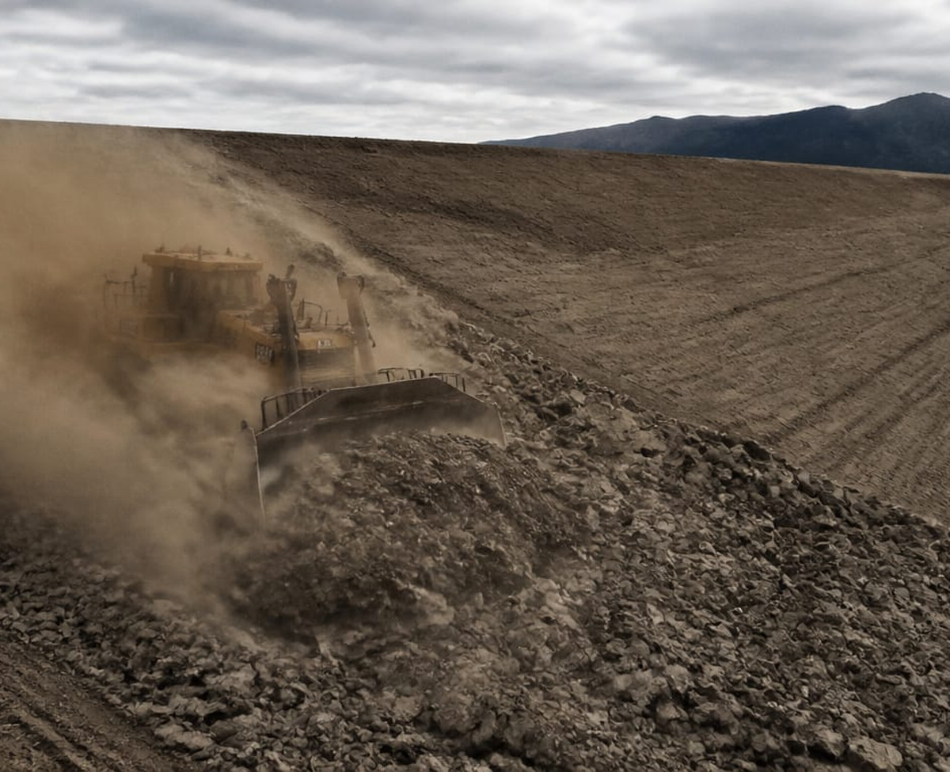
CAT D11 Bulldozer Largest production bulldozer · 850 horsepower
FEBRUARY 2027
SUN | MON | TUE | WED | THU | FRI | SAT
7 | 1 | 2 | 3 | 4 | 5 | 6
14 | 8 | 9 | 10 | 11 | 12 | 13
21 | 15  Washington's Birth | 16 | 17 | 18 | 19 | 20
28 | 22 | 23 | 24 | 25 | 26 | 27
Libraria Spei et Miraculorum · Heavy Equipment 2027

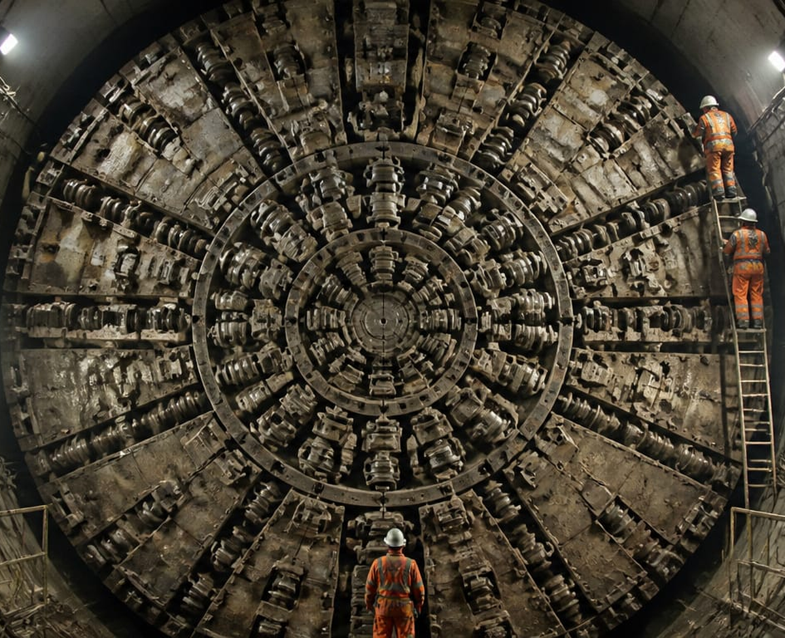
Tunnel Boring Machine Cuts through solid rock · diameter up to 19 metres
MARCH 2027
SUN | MON | TUE | WED | THU | FRI | SAT
7 | 1 | 2 | 3 | 4 | 5 | 6
14 | 8 | 9 | 10 | 11 | 12 | 13
21 | 15 | 16 | 17 | 18 | 19 | 20
28 | 22 | 23 | 24 | 25 | 26 | 27
 | 29 | 30 | 31
Libraria Spei et Miraculorum · Heavy Equipment 2027

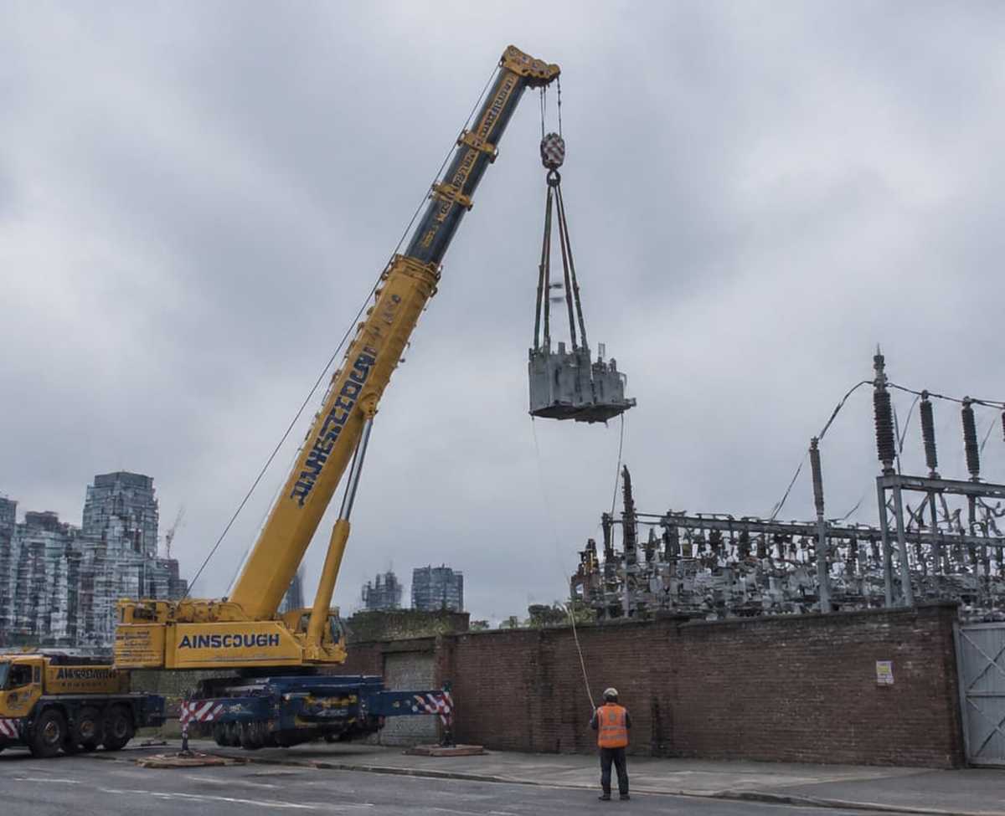
Liebherr LTM 1750-9.1 Mobile Crane 750-tonne lift capacity · travels on public roads
APRIL 2027
SUN | MON | TUE | WED | THU | FRI | SAT
4 |  |  |  | 1 | 2 | 3
11 | 5 | 6 | 7 | 8 | 9 | 10
18 | 12 | 13 | 14 | 15 | 16 | 17
25 | 19 | 20 | 21 | 22 | 23 | 24
 | 26 | 27 | 28 | 29 | 30
Libraria Spei et Miraculorum · Heavy Equipment 2027

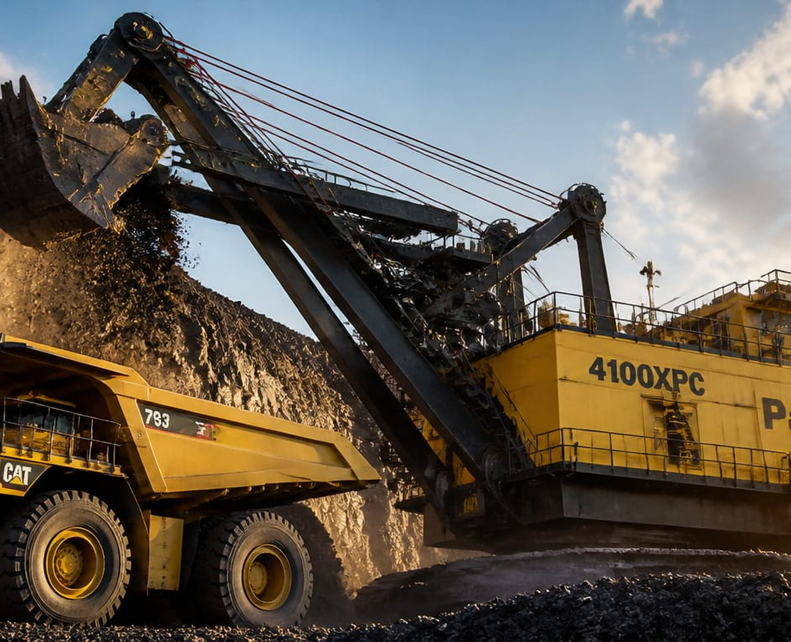
P&H 4100XPC Electric Mining Shovel 120-tonne dipper · digs 15 metres deep in one pass
MAY 2027
SUN | MON | TUE | WED | THU | FRI | SAT
2 |  |  |  |  |  | 1
9 | 3 | 4 | 5 | 6 | 7 | 8
16 | 10 | 11 | 12 | 13 | 14 | 15
23 | 17 | 18 | 19 | 20 | 21 | 22
30 | 24 | 25 | 26 | 27 | 28 | 29
31
Memorial Day
Libraria Spei et Miraculorum · Heavy Equipment 2027

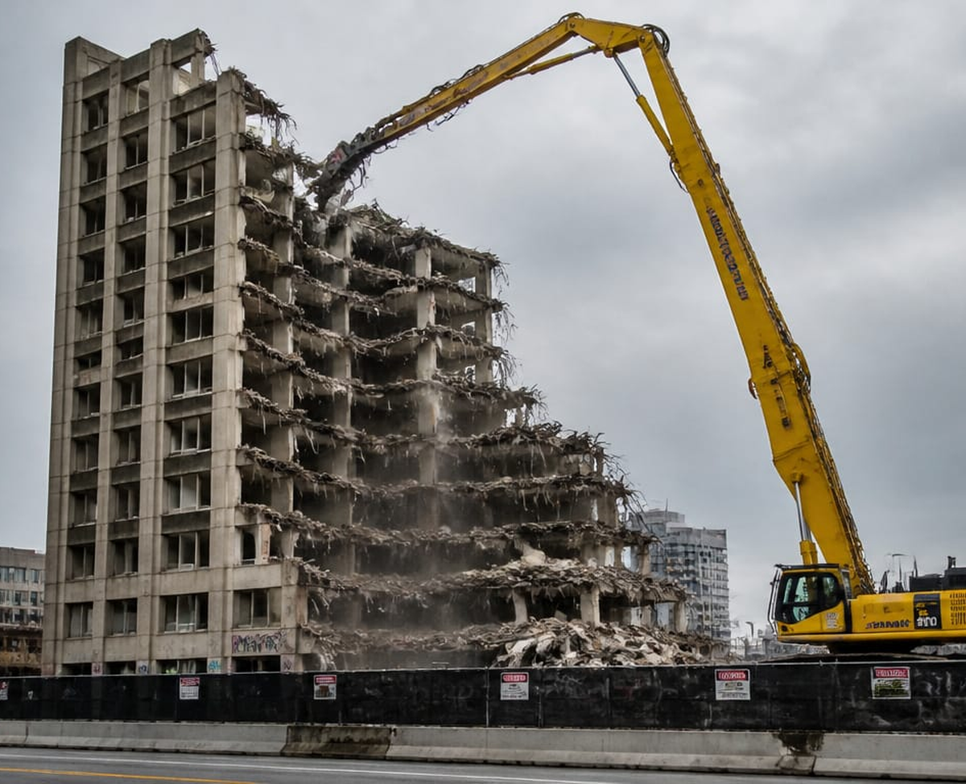
Komatsu PC800 Hydraulic excavator · 80-tonne operating weight
JUNE 2027
SUN | MON | TUE | WED | THU | FRI | SAT
6 |  | 1 | 2 | 3 | 4 | 5
13 | 7 | 8 | 9 | 10 | 11 | 12
20 | 14 | 15 | 16 | 17 | 18  Juneteenth Nationa | 19  Juneteenth Nationa
27 | 21 | 22 | 23 | 24 | 25 | 26
 | 28 | 29 | 30
Libraria Spei et Miraculorum · Heavy Equipment 2027

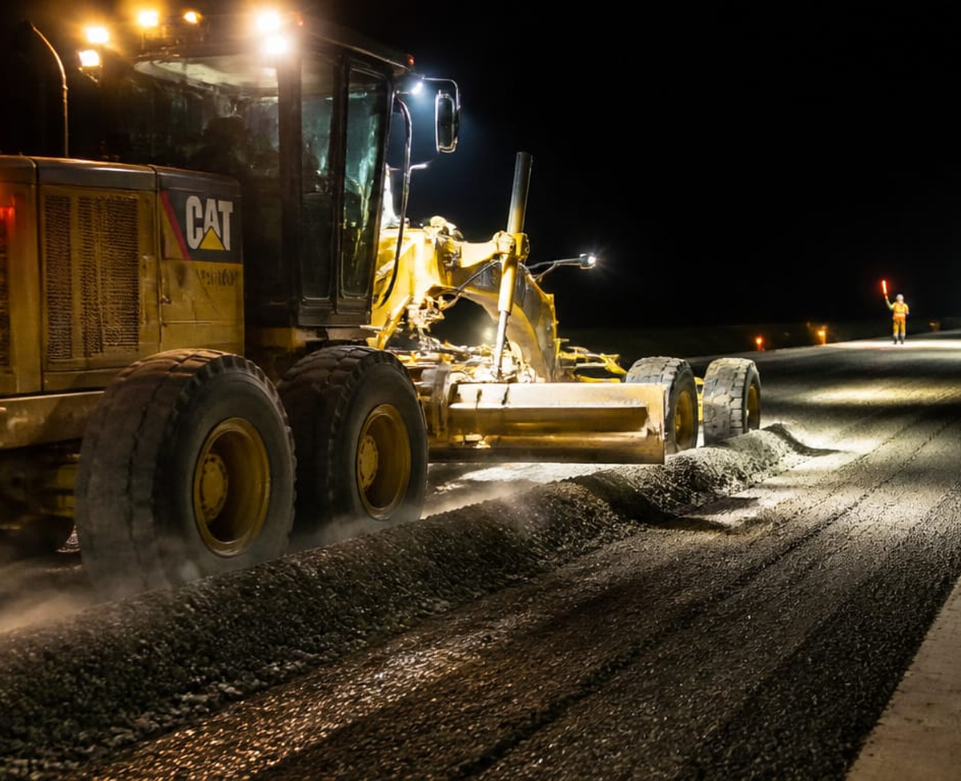
CAT 16M Motor Grader Largest production grader · 7.3-metre blade
JULY 2027
SUN | MON | TUE | WED | THU | FRI | SAT
4  Independence Day |  |  |  | 1 | 2 | 3
11 | 5  Independence Day ( | 6 | 7 | 8 | 9 | 10
18 | 12 | 13 | 14 | 15 | 16 | 17
25 | 19 | 20 | 21 | 22 | 23 | 24
 | 26 | 27 | 28 | 29 | 30 | 31
Libraria Spei et Miraculorum · Heavy Equipment 2027

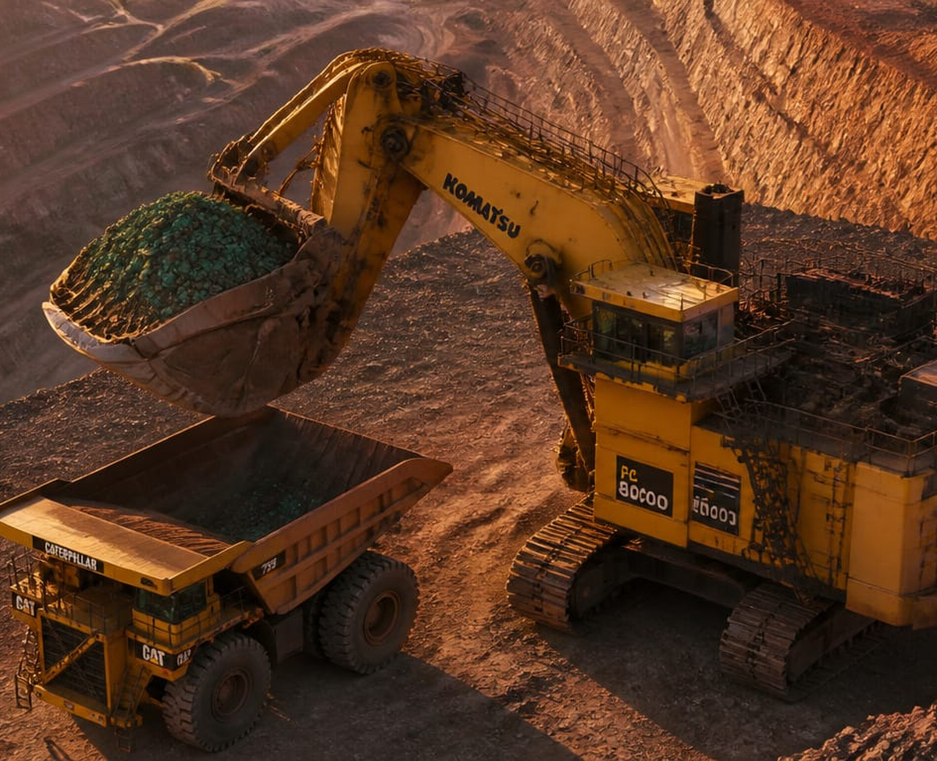
Komatsu PC8000-11 Face Shovel 800-tonne machine · fills a 240-tonne truck in 3 passes
AUGUST 2027
SUN | MON | TUE | WED | THU | FRI | SAT
1
8 | 2 | 3 | 4 | 5 | 6 | 7
15 | 9 | 10 | 11 | 12 | 13 | 14
22 | 16 | 17 | 18 | 19 | 20 | 21
29 | 23 | 24 | 25 | 26 | 27 | 28
 | 30 | 31
Libraria Spei et Miraculorum · Heavy Equipment 2027

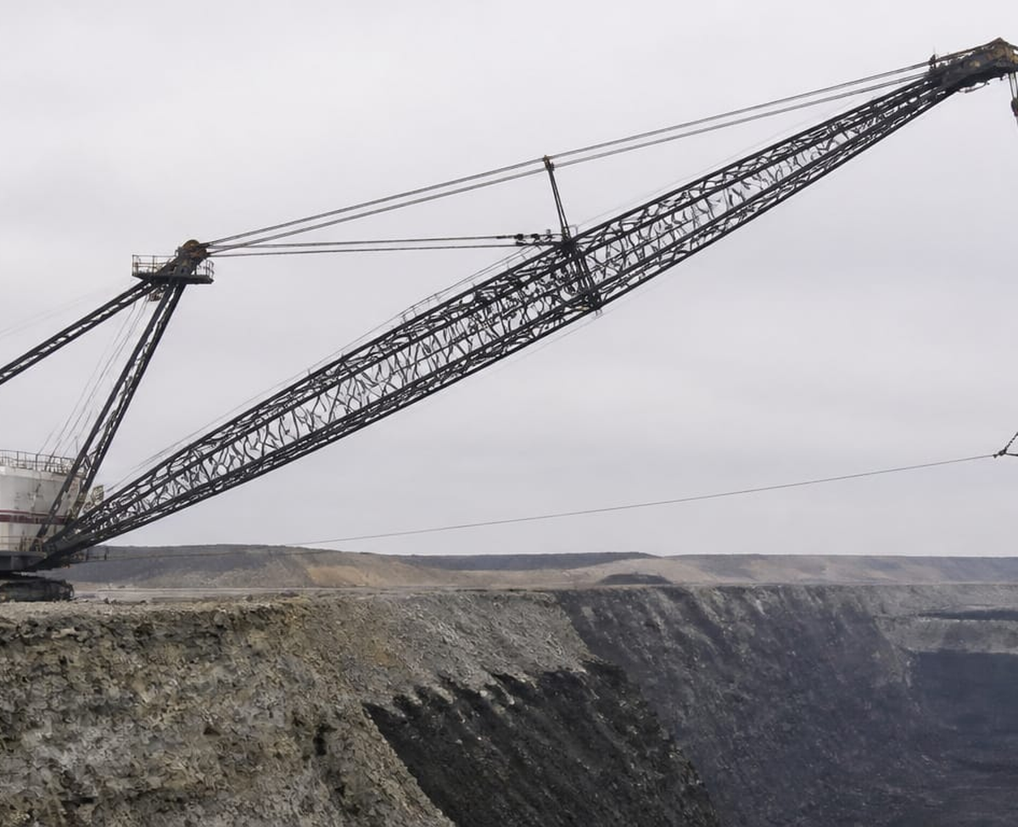
Bucyrus 8750 Dragline Crane Walking dragline · bucket holds 168 cubic metres
SEPTEMBER 2027
SUN | MON | TUE | WED | THU | FRI | SAT
5 |  |  | 1 | 2 | 3 | 4
12 | 6  Labor Day | 7 | 8 | 9 | 10 | 11
19 | 13 | 14 | 15 | 16 | 17 | 18
26 | 20 | 21 | 22 | 23 | 24 | 25
 | 27 | 28 | 29 | 30
Libraria Spei et Miraculorum · Heavy Equipment 2027

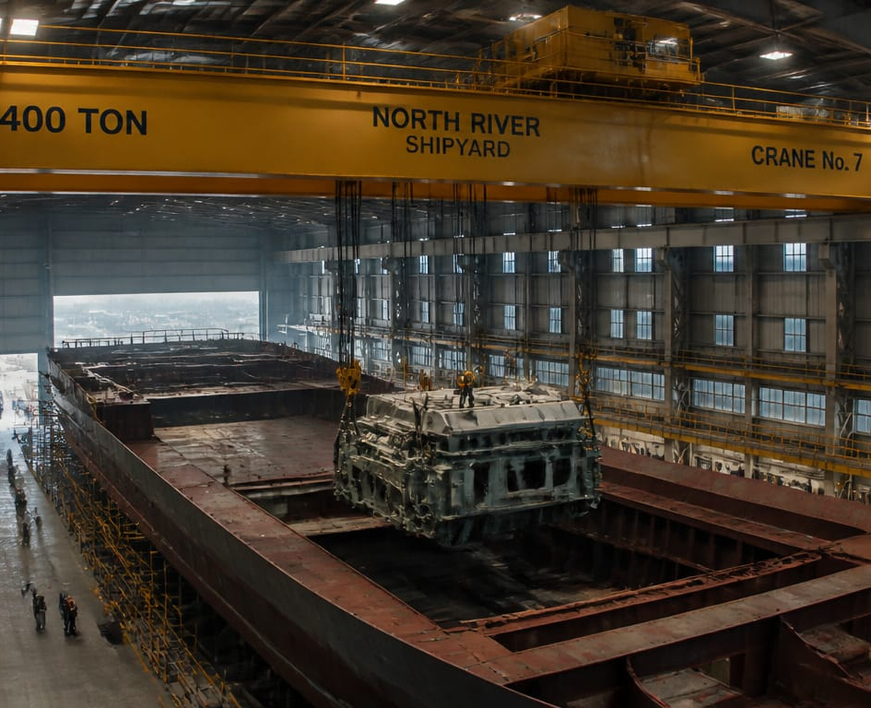
Shipyard Overhead Gantry Crane Lifts entire ship hull sections into place
OCTOBER 2027
SUN | MON | TUE | WED | THU | FRI | SAT
3 |  |  |  |  | 1 | 2
10 | 4 | 5 | 6 | 7 | 8 | 9
17 | 11  Columbus Day | 12 | 13 | 14 | 15 | 16
24 | 18 | 19 | 20 | 21 | 22 | 23
31 | 25 | 26 | 27 | 28 | 29 | 30
Libraria Spei et Miraculorum · Heavy Equipment 2027

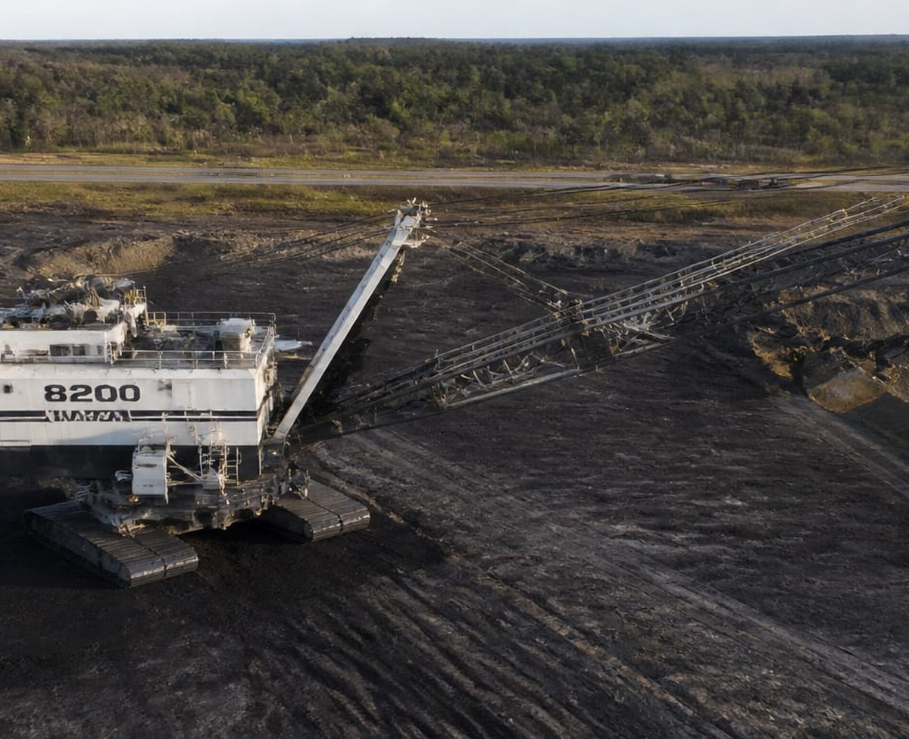
Marion 8200 Walking Dragline Coal mining dragline · moves on giant steel shoes
NOVEMBER 2027
SUN | MON | TUE | WED | THU | FRI | SAT
7 | 1 | 2 | 3 | 4 | 5 | 6
14 | 8 | 9 | 10 | 11  Veterans Day | 12 | 13
21 | 15 | 16 | 17 | 18 | 19 | 20
28 | 22 | 23 | 24 | 25  Thanksgiving Day | 26 | 27
 | 29 | 30
Libraria Spei et Miraculorum · Heavy Equipment 2027

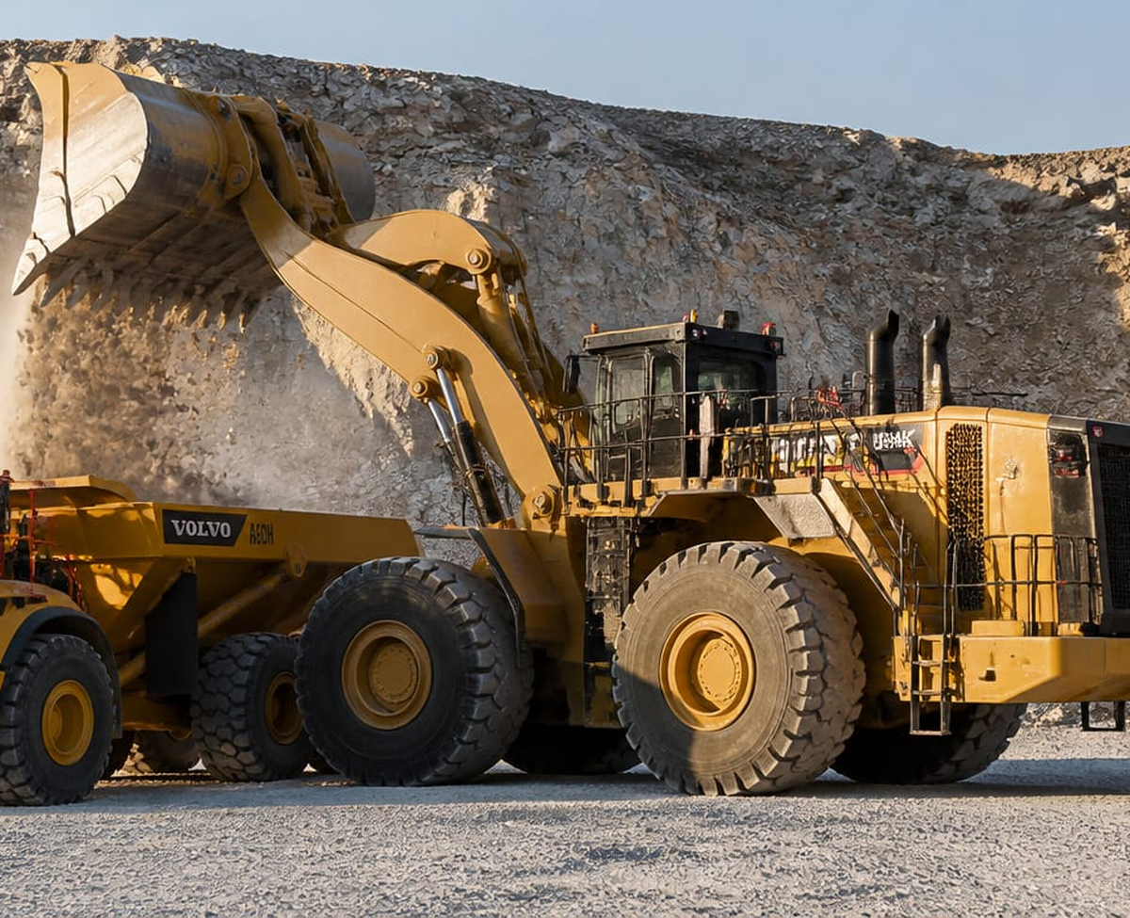
CAT 994K Wheel Loader Largest wheel loader · 41-tonne payload capacity
DECEMBER 2027
SUN | MON | TUE | WED | THU | FRI | SAT
5 |  |  | 1 | 2 | 3 | 4
12 | 6 | 7 | 8 | 9 | 10 | 11
19 | 13 | 14 | 15 | 16 | 17 | 18
26 | 20 | 21 | 22 | 23 | 24  Christmas Day (obs | 25  Christmas Day
 | 27 | 28 | 29 | 30 | 31  New Year's Day (ob
Libraria Spei et Miraculorum · Heavy Equipment 2027

www.librariaspei.com

